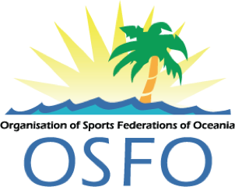

2022 OSFO Annual Assembly

Thursday May 5, 2022 3.00 – 7.00pm

Sheraton Resort, Denuaru Island Nadi, Fiji plus Zoom Conference
Agenda
Draft

- Zoom Conference guidelines – Chet
- Roll Call – Chet
- Acknowledge individuals who have passed away in the region involved with sport.

- Official Opening OSFO Annual General Meeting – Kevan Gosper
  - 2022 OSFO Merit Award announcements
  - President’s report
  - Oceania Australia Foundation update – Helen McMurray

- PGC presentation – Andrew Minogue on behalf of PGC President Vidhya Lakhan

- Review of previous minutes – Chet Gray
  - OSFO Financial report – 2021
  - Secretary General report

- Major Project Report – Edwina Ricci
  - Athlete Well Being and Resilience Program – Hope Leaders program

- OSEP Sport Education Commission Report - Gill Gemming, Regan Kama

- Team Up – Pacific Sports – Ben Howard and Andrew Lepani

- Athletes Commission presentation ‘The Athletes Panel’ - Ryan Pini

- OSFO Strategic Plan 2022-2026 – Helen Smith and Brooke Kneebush

- General Business

