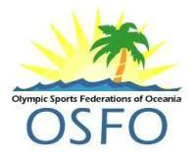

Olympic Sports Federations of Oceania
Merit Award
Criteria

- A Merit Award may be granted to a member of an affiliated Member Federation or Associate Member Federation who has rendered distinguished service to the Olympic Sports Federations of Oceania (OSFO).

- A Merit Award may be granted to a member of an affiliated Member Federation or Associate Member Federation who has rendered distinguished service to their chosen Sport in the Oceania Region.

- The Awardee should have rendered distinguished service for a period of not less than eight (8) years.

- A nomination in any year for a Merit Award shall be submitted to the OSFO Executive together with a written report outlining the services rendered by the nominee.

- The OSFO Executive may submit nominations for the award of OSFO Merit Award.

- OSFO Merit Awards will be awarded annually to no more than four (4) nominees across the sports in the Oceania Region.

- A Merit Award will be granted to the nominee if:

The nomination receives a two-third majority of votes cast at an OSFO Executive meeting in favour of the nomination and confirmed by a two-third majority of votes cast at the General Assembly.

- A recipient of a Merit Award shall be awarded a badge of a design approved by the Association.

